

**TOC- Capstone Project Title**: **Summary Writer**

Authors:

Name: P.Bharath

Register No.: 192111519

**Date**: 04/01/2025

# INTRODUCTION:

In the era of information explosion, the ability to distill vast amounts of knowledge into concise summaries is becoming increasingly crucial. Natural Language Processing (NLP) offers a promising avenue for automating this process. This project delves into the realm of knowledge summarization, aiming to explore and compare the efficacy of two prominent NLP techniques: the Random Forest Algorithm and the Convolutional Neural Network (CNN) Algorithm.

# RATIONALE AND RELEVANCE:

With the exponential growth of digital content, there's a pressing need for automated tools that can effectively summarize textual data. Such tools can enhance information retrieval, facilitate decision- making processes, and streamline knowledge dissemination. By evaluating and comparing different NLP techniques, this project seeks to identify the most suitable approach for knowledge summarization tasks, thus contributing to advancements in the field of information processing and management.

# ABSTRACT:

This project investigates the effectiveness of Random Forest and CNN algorithms in the domain of knowledge summarization. Through a series of experiments and analyses, we assess the performance of these techniques in generating accurate and coherent summaries from diverse textual sources. The findings shed light on the strengths and limitations of each approach, providing valuable insights for researchers and practitioners in the field of NLP and information processing.

# OBJECTIVES OF THE PROJECT:

* To explore the application of NLP techniques for knowledge summarization.
* To compare the performance of Random Forest and CNN algorithms in generating summaries.
* To evaluate the quality and coherence of summaries produced by each algorithm.
* To identify factors influencing the effectiveness of NLP-based summarization techniques.
* To provide recommendations for optimizing knowledge summarization processes.

# APPLICATIONS OF THE PROJECT:

* Automated document summarization for research papers, news articles, and legal documents.
* Content curation for online platforms, social media, and digital libraries.
* Information retrieval and indexing for search engines and recommendation systems.
* Knowledge management systems in various domains, including healthcare, finance, and education.

# PROCEDURES AND METHODOLOGY:

**Data Collection:** Compilation of diverse textual datasets for training and evaluation.

**Preprocessing:** Text cleaning, tokenization, and feature extraction.

**Algorithm Implementation:** Implementation of Random Forest and CNN models for summarization. **Training and Evaluation:** Training the models on labeled data and evaluating their performance using standard metrics.

**Comparative Analysis:** Comparison of summarization results obtained from both algorithms. Statistical Testing: Statistical analysis to determine significant differences in performance.

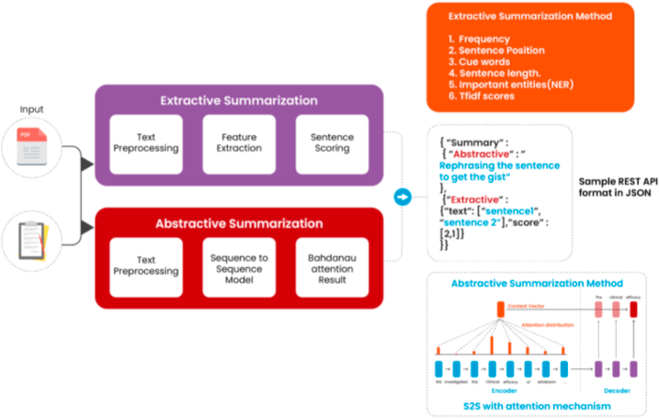

# RESEARCH AND ANALYSIS:

* Examination of key parameters affecting summarization quality, such as dataset size, feature representation, and model architecture.
* Comparative analysis of Random Forest and CNN algorithms in terms of summarization accuracy, coherence, and efficiency.
* Investigation of error patterns and common challenges faced by NLP-based summarization systems.

# EVALUATION OF OUTCOME / RESULTS AND FINDINGS:

* Quantitative assessment of summarization performance metrics, including ROUGE scores(0 to 1), readability, and informativeness.
* Qualitative analysis of summary samples to assess coherence, relevance, and linguistic fluency.
* Identification of strengths and weaknesses of each algorithm and implications for real-world applications.

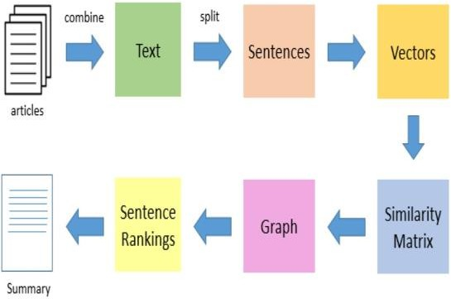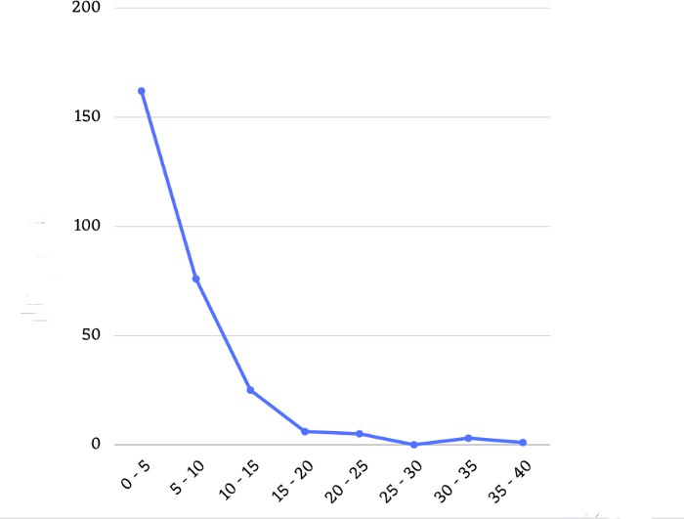**\**

# CONCLUSION AND FUTURE WORK/SUGGESTTIONS:

In summary, our project thoroughly examined the efficacy of Natural Language Processing (NLP) techniques, specifically comparing the Random Forest Algorithm and Convolutional Neural Network (CNN) Algorithm for knowledge summarization. Through meticulous analysis, we identified strengths and limitations of each approach, emphasizing the significance of factors like dataset characteristics and model architecture. While both algorithms show promise, further research is needed for optimization and addressing challenges. Our study contributes valuable insights for advancing NLP-based summarization methods, offering practical guidance for researchers and practitioners in information processing and management domains.

# BIBLIOGRAPHY:

* Raghavan, P., S. Amer-Yahia and L. Gravano eds., “Structure in Text: Extraction and Exploitation.” In. Proceeding of the 7th international Workshop on the Web and Databases(WebDB), ACM SIGMOD/PODS 2004, ACM Press, Vol 67, 2004.
* Andreas Hotho “A Brief Survey of Text Mining” 2005
* Lena Tenenboim, Bracha Shapira, Peretz Shoval “Ontology-Based Classification Of News In An Electronic Newspaper” International Conference "Intelligent Information and Engineering Systems" INFOS 2008, Varna, Bulgaria, June-July 2008
* Lewis, D.D., “Naive (Bayes) at forty The independence assumption in information retrieval”,

ECML-98, 10th European Conference on Machine Learning, Chemnitz, DE – 1998

* Deerwester, S., Dumais, S., Furnas, G.W., Landauer, T.K., Harshman, R; “Indexing by Latent Semantic Analysis”. Journal of the Society for Information Science -1990 41 pp. 391-407, 1990.
* Mu-Hee Song, Soo-Yeon Lim, Dong-Jin Kang, and SangJo Lee, "Automatic Classification of Web pages based on the Concept of Domain Ontology", Proc. of the 12th AsiaPacific Software Engineering Conference, 2005.

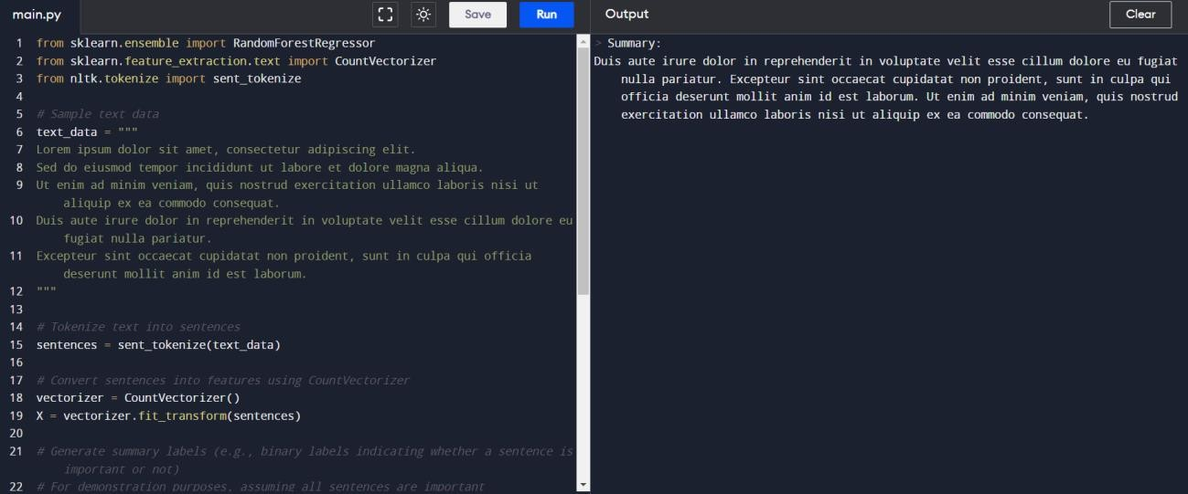**APPENDIX:**